
Tertiary Infotech Academy Pte Ltd
UEN: 201200696W
LESSON PLAN
For
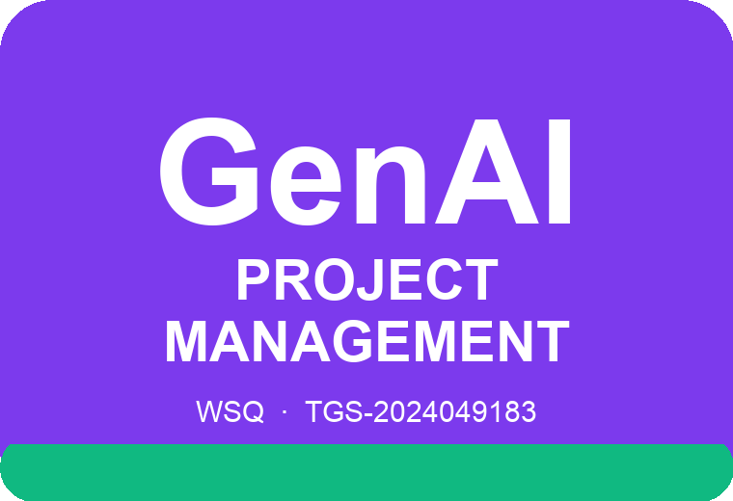
Generative AI for Project Management
Course Code: C013
Conducted by
Tertiary Infotech Academy Pte Ltd
UEN: 201200696W
Version 1.0

DOCUMENT VERSION CONTROL RECORD
Version Number | Effective Date of Release | Summary of Included Changes | Author
1.0 | 19 September 2026 | First release of the non-WSQ Lesson Plan for Generative AI for Project Management (C013). Two days, 7.5 instructional hours per day, 9:30 am - 5:30 pm. | Dr Alfred Ang

TABLE OF CONTENTS

Course Information 4
Learning Outcomes 4
Course Schedule 4
Day 1 — Initiation & Planning with GenAI 4
Day 2 — Execution, Risk & Closure with GenAI 5
Activity and Slide Reference 7

Course Information
Course Title | Generative AI for Project Management
Course Reference | C013
Training Provider | Tertiary Infotech Academy Pte Ltd (UEN 201200696W)
Duration | 2 days · 7.5 instructional hours per day (15 hours)
Daily Timing | 9:30 am – 5:30 pm (30-minute lunch; refreshments during activity time)
Mode | Instructor-led, with 25 hands-on GenAI activities using ChatGPT/Claude/Gemini/Copilot and five browser-based project management ed-tools
Trainer | Dr Alfred Ang

Learning Outcomes
On completion of this course, learners will be able to:
- LO1: Develop project parameters with GenAI according to business requirements.
- LO2: Resolve project delivery challenges by optimising resource and project budgets with GenAI.
- LO3: Anticipate and devise risk mitigation measures with GenAI to ensure project success.

Course Schedule

Day 1 — Initiation & Planning with GenAI
Time | Duration | Topic / Activity
9:30–10:00 | 30 min | Welcome, trainer and learner introductions, ground rules, course outline and learning outcomes.
10:00–11:00 | 60 min | Topic 1 — Project Initiation and Planning with GenAI: what a project is, the triple constraint, PM competencies, life cycles, predictive vs adaptive delivery, and GenAI fundamentals for the project manager.
11:00–13:00 | 120 min | Ten prompting patterns for project managers; the five course ed-tools. Hands-on: Activity 1: Prompting Patterns for Project Managers.
13:00–13:30 | 30 min | Lunch break
13:30–15:00 | 90 min | Project charter, business value, kickoff; stakeholder identification, salience and engagement. Hands-on: Activity 2: Business Case and Cost-Benefit Analysis; Activity 3: Develop the Project Charter; Activity 4: Identify and Map Stakeholders; Activity 5: Assign Responsibilities with the RACI Ed-Tool.
15:00–17:15 | 135 min | Scope and requirements, RTM, WBS and WBS dictionary; schedule, dependencies, estimating and the critical path; cost estimating, budgets and reserves. Hands-on: Activity 6: Collect Requirements; Activity 7: Build the RTM; Activity 8: Decompose Scope into a WBS; Activity 9: Build the Schedule and Find the Critical Path; Activity 10: Estimate Costs and Build the Budget.
17:15–17:30 | 15 min | Day 1 recap and Q&A. End of Day 1.
Total instructional time: 450 minutes (7.5 hours), 9:30 am – 5:30 pm.

Day 2 — Execution, Risk & Closure with GenAI
Time | Duration | Topic / Activity
9:30–9:45 | 15 min | Day 1 recap and Q&A.
9:45–11:00 | 75 min | Topic 2 — Project Execution and Delivery with GenAI: directing project work, work performance data/information/reports, and managing project knowledge. Hands-on: Activity 11: Direct Project Work and Report Performance; Activity 12: Manage Project Knowledge.
11:00–13:00 | 120 min | Quality management, cost of quality, root cause analysis, PDCA and DMAIC; resource optimisation and schedule compression. Hands-on: Activity 13: Root Cause Analysis; Activity 14: Continuous Improvement; Activity 15: Optimise Resources and Budget.
13:00–13:30 | 30 min | Lunch break
13:30–14:45 | 75 min | Team development, Tuckman's ladder, conflict management and communications planning. Hands-on: Activity 16: Develop and Manage the Team; Activity 17: Plan and Manage Communications.
14:45–17:15 | 150 min | Topic 3 — Managing Project Risks with GenAI: risk vs issue, identification, qualitative and quantitative analysis, risk responses; procurement and contracts; monitoring and control, earned value, quality control and project closure. Hands-on: Activities 18–25.
17:15–17:30 | 15 min | Course recap, feedback and close. End of Day 2.
Total instructional time: 450 minutes (7.5 hours), 9:30 am – 5:30 pm.

Activity and Slide Reference
Each activity uses the matching folder under activities/. The prompt shown on the listed deck slide is reproduced in the Learner Guide and in that folder's prompts.pdf.
Topic | Learning outcome / TSC | Activity | Deck slides
Topic 01: Project Initiation and Planning with GenAI | LO1 · K2, A1 | Activity 1: Prompting Patterns for Project Managers | 49-51 (prompt 50)
Topic 01: Project Initiation and Planning with GenAI | LO1 · K2, A1 | Activity 2: Business Case and Cost-Benefit Analysis with GenAI | 67-69 (prompt 68)
Topic 01: Project Initiation and Planning with GenAI | LO1 · K2, A1 | Activity 3: Develop the Project Charter with GenAI | 73-75 (prompt 74)
Topic 01: Project Initiation and Planning with GenAI | LO1 · K2, A1 | Activity 4: Identify and Map Stakeholders with GenAI | 87-89 (prompt 88)
Topic 01: Project Initiation and Planning with GenAI | LO1 · K2, A1 | Activity 5: Assign Responsibilities with the RACI Ed-Tool | 92-94 (prompt 93)
Topic 01: Project Initiation and Planning with GenAI | LO1 · K2, A1 | Activity 6: Collect Requirements with GenAI and Design Thinking | 100-102 (prompt 101)
Topic 01: Project Initiation and Planning with GenAI | LO1 · K2, A1 | Activity 7: Build the Requirements Traceability Matrix with GenAI | 105-107 (prompt 106)
Topic 01: Project Initiation and Planning with GenAI | LO1 · K2, A1 | Activity 8: Decompose Scope into a WBS and WBS Dictionary with GenAI | 115-117 (prompt 116)
Topic 01: Project Initiation and Planning with GenAI | LO1 · K2, A1 | Activity 9: Build the Schedule and Find the Critical Path with GenAI | 127-129 (prompt 128)
Topic 01: Project Initiation and Planning with GenAI | LO1 · K2, A1 | Activity 10: Estimate Costs and Build the Budget with GenAI | 134-136 (prompt 135)
Topic 02: Project Execution and Delivery with GenAI | LO2 · K3, A2 | Activity 11: Direct Project Work and Report Performance with GenAI | 146-148 (prompt 147)
Topic 02: Project Execution and Delivery with GenAI | LO2 · K3, A2 | Activity 12: Manage Project Knowledge with GenAI | 150-152 (prompt 151)
Topic 02: Project Execution and Delivery with GenAI | LO2 · K3, A2 | Activity 13: Root Cause Analysis with GenAI — Fishbone, Five Whys and Pareto | 159-161 (prompt 160)
Topic 02: Project Execution and Delivery with GenAI | LO2 · K3, A2 | Activity 14: Continuous Improvement with GenAI — PDCA and DMAIC | 164-166 (prompt 165)
Topic 02: Project Execution and Delivery with GenAI | LO2 · K3, A2 | Activity 15: Optimise Resources and Budget with GenAI | 172-174 (prompt 173)
Topic 02: Project Execution and Delivery with GenAI | LO2 · K3, A2 | Activity 16: Develop and Manage the Team with GenAI | 184-186 (prompt 185)
Topic 02: Project Execution and Delivery with GenAI | LO2 · K3, A2 | Activity 17: Plan and Manage Communications with GenAI | 195-197 (prompt 196)
Topic 03: Managing Project Risks with GenAI | LO3 · K1, A3, A4 | Activity 18: Identify Project Risks with GenAI | 210-212 (prompt 211)
Topic 03: Managing Project Risks with GenAI | LO3 · K1, A3, A4 | Activity 19: Qualitative Risk Analysis with GenAI | 216-218 (prompt 217)
Topic 03: Managing Project Risks with GenAI | LO3 · K1, A3, A4 | Activity 20: Quantitative Risk Analysis with GenAI — Tornado Charts and Decision Trees | 220-222 (prompt 221)
Topic 03: Managing Project Risks with GenAI | LO3 · K1, A3, A4 | Activity 21: Plan Risk Responses with GenAI | 225-227 (prompt 226)
Topic 03: Managing Project Risks with GenAI | LO3 · K1, A3, A4 | Activity 22: Plan Procurement and Manage Contracts with GenAI | 234-236 (prompt 235)
Topic 03: Managing Project Risks with GenAI | LO3 · K1, A3, A4 | Activity 23: Earned Value Analysis with GenAI | 248-250 (prompt 249)
Topic 03: Managing Project Risks with GenAI | LO3 · K1, A3, A4 | Activity 24: Control Quality with GenAI — Check Sheets and Control Charts | 255-257 (prompt 256)
Topic 03: Managing Project Risks with GenAI | LO3 · K1, A3, A4 | Activity 25: Monitor, Control Change and Close the Project with GenAI | 263-265 (prompt 264)

